**City Gynaecare Clinic**

**Dr Meenakshi Sharma**

***MBBS(AIIMS), MD (Obs&Gynae) (AIIMS), FICOG, FICMCH***

**Antenatal Exercises**

**Antenatal exercises help in toning the body, reduce back pain, prevent excessive weight gain, make labour easier and help in faster recovery after childbirth.**

**How do you exercise when you’re pregnant?**

If exercising has always been a part of your life, then you should be able to continue working out with some modifications so long as you have a healthy and normal pregnancy. If you’re just beginning your physical activity, start slowly. Depending on how you feel, you can begin with a 15-minute walk and gradually work your way up to 45 minutes every day.

**How much exercise is enough?**

There’s no perfect answer to how much exercise is enough. Antenatal exercises depend on an individual’s pre-pregnancy level of fitness. But on an average, women should walk for 30-45 minutes every day and do 20-30 minutes of specifically designed antenatal exercises.

**What are the precautions to be taken while exercising?**

We recommend the following precautions:

* Avoid walks or outdoor exercises in the early morning and early evening hours because these are peak times for pollution. If you can’t alter your times, use a mask.
* Keep yourself hydrated throughout the day. If the taste of water makes you feel nauseous, try lemonade or coconut water instead.
* Do your best to walk in a park or on a treadmill. If you walk on the streets, walk on the right side facing the oncoming traffic
* Warm up slowly, use stretching exercises but avoid overstretching to prevent injury to ligaments.
* Avoid jerking or jumping exercises.
* Exercise regularly
* Be careful of loose throw of rugs that could slip and injury while doing floor exercises
* After first three months avoid exercises that require supine position
* If you feel exhausted, dizzy or experience pain, bleeding or cramps at any time during your workouts, you should stop immediately and call your doctor.
* Exercise helps you cope better with the aches and pains of pregnancy and builds the stamina you will need during labour – make sure you don’t neglect it!

**What are the conditions when it is not safe to exercise during pregnancy?**

* Any episode of vaginal bleeding
* When having severe anemia
* When there is history of preterm labor
* Extreme over or underweight
* Heart disease, Hypertension or lung disease

**What are the exercises to be done during pregnancy?**

Walking for 30-45 minutes is one of the safest exercises for pregnant women because of its low impact. Make sure you wear comfortable shoes and loose fitting clothes for easy movement.

Walk at a conversational pace –aim to walk briskly but at a level that you can still comfortably talk to someone next to you. You can try swimming or water aerobics if you have access to a pool; water exercises will help relieve the pressure on your back.

You can also sign up for an antenatal class that will help you stay flexible and reduce stress through various poses and breathing exercises.

### **Leg exercises**

How to do this exercise:

* Bending and stretching your foot slowly up and down 30 times feeling the stretch.
* Rotating your foot 10 times one way and 10 times the other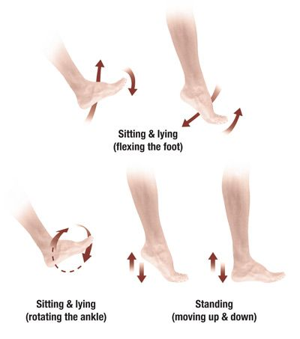
* Repeating with the other foot
* You can do these exercises while sitting in chair or lying down or even standing

You should do the specific foot and leg muscle exercises as it prevents leg cramps.

Stretching your calf muscles before you go to bed might help to prevent cramps at night.

### **Squats**

How to do this exercise:

* + Stand straight and move your feet so they are shoulder-width apart.
  + Hold your arms straight out in front of your body to steady yourself.
  + Lower yourself into a squat position. Move down only as much as you can while maintaining a straight back and putting the weight in your heels.
  + Make sure your knees aren’t bending too much. They should be behind or in line with your toes.
  + Go back to the starting position, squeezing your glutes on the way up.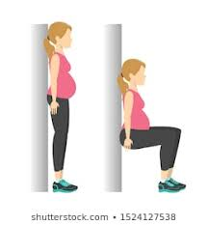
* You may also do this exercise by holding onto a chair or your husband/ birth partner.
* Squats help in many ways:
  + Increasing strength of pelvic floor muscles.
  + Preventing back and pelvic pain.
* Helping the baby to descend down into the pelvis during labour.

### **Butterfly Exercise or Purna Titli Asana**

How to do the exercise:

* + Sit on the floor with your back straight. Stretch out your legs in front of you and then straighten them.
  + Slowly bend your knees and bring your feet towards your pelvis.
  + Bring the soles of your feet together and move them as close to your groin as you can.
  + Make sure your knees point in opposite directions while your feet are held together.
  + Move your knees up and then slowly press your knees towards the floor. Press slowly. Take your knees as low as they can go. Don’t pressure yourself if they’re not going all the way down.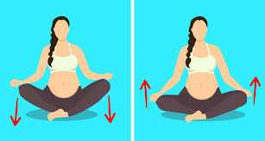
* Move your knees up and then press them gently down again. Repeat as many times as is comfortable for you.

This is one of the simplest antenatal exercises and helps by:

* + Strengthening pelvic muscles
  + Stretching areas in inner thigh and opening up the hip during pregnancy, which aids in delivery
* Helping regulate bowel movements

### **Back exercise - Cat and Camel Exercise (All Fours)**

How to do the exercise:

* + Bend down until you are on your hands and knees on the floor. Let your head relax and allow it to droop.
  + Move your back upwards and toward the ceiling. Doing this should stretch your upper, middle, and lower back.
  + When you feel the stretch, hold it for as long as you can. Otherwise 15 to 30 seconds should be enough.
  + Go back to the starting position and flatten your back while you are on all fours.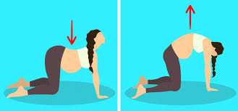
  + Lower your stomach toward the floor. Allow your back to swing slightly.
* Raise your buttocks toward the ceiling.

This exercise during pregnancy helps:

* + Improve posture and balance
  + Stretch hip, abdomen and back
* Tone up abdominal muscles in a safe manner

### **Bridge Exercise**

How to do this exercise:

* + Lie down on your back
  + Bend your knees and position them a few inches away from your buttocks
  + Push into your feet and squeeze your glutes (buttock muscles) until your buttock is raised off the ground
* Try to hold this position for as long as you can, without tiring yourself, and then go back to the original position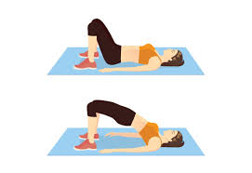

Bridging exercise helps:

* + Tone quadriceps, hamstrings, abdominals and buttocks
* Strengthen hips and pelvis which helps with a normal delivery

Finally, you should also practice breathing exercises. Doing these in labour will help you keep calm by taking your mind off the [pain of labour](https://www.sitarambhartia.org/blog/reduce-labour-pain/).

### **Breathing Exercise**

How to do the exercise:

* + Sit down with your back straight.
  + Place your right hand on the belly and left hand on your chest.
  + Breath in through your nose. As you breathe in, the abdomen will push your hand up.
  + Your chest should be still during this process.
  + Now slowly breath out through your mouth.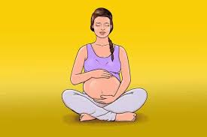
* Your belly should deflate while you exhale.

Breathing exercises in the antenatal period and during active labour help you to:

* + Stay calm and de-stress
  + Better manage your contractions and labour pain
* Fulfill the additional need of oxygen during pregnancy. Deep breathing exercises provide you more oxygen which provide relief from joint and muscle pain.

Exercising during pregnancy is safe and healthy and should be done under expert supervision.