**City Gynaecare Clinic**

**Dr Meenakshi Sharma**

***MBBS(AIIMS), MD (Obs&Gynae) (AIIMS), FICOG, FICMCH***

**Diet in Pregnancy**

**Well-balanced diet for pregnancy**

A balanced diet means that you consume a certain amount of products from the four main food groups. It is considered a healthy way of planning your meals at any time of life, but it is pregnancy when this approach is of the utmost importance as it helps your body meet its growing nutritional needs.

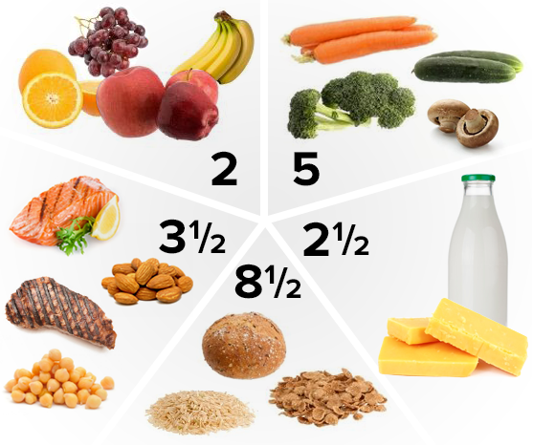

**What You Should Eat During Pregnancy**

You should include **4 essential food groups** in your pregnancy diet chart. Each of these contains Indian foods that will meet your nutritional needs as well as your baby’s.

1. **Lean Protein** - Foods such as lentils, beans, cheese, milk, fish, eggs, meat, tofu, and nuts are a rich source of protein. These foods are essential for your baby’s growth and development during pregnancy.
2. **Whole Grains** - Switch to multigrain chapati, whole wheat pasta, oatmeal, wheat bread and brown rice. At least half of your carbohydrates in a day should come from such whole grains.
3. **Dairy** - Dairy should be an important component of your pregnancy diet plan.  Foods such as curd/yoghurt (dahi), milk and cottage cheese (paneer) provide the much needed calcium, protein and vitamin D for your baby’s bones.
4. **Fruits and vegetables** - Make it a point to eat vegetables with little or no oil to avoid excessive weight gain. Fruits and vegetables of different colours are rich in fibre, vitamins and minerals and are low in calories.

**What to avoid in pregnancy?**

The main foods to avoid during pregnancy include processed foods such as ready to eat food or packaged food items; undercooked meat and unwashed produce. Bingeing on foods with a high fat content can also cause unnecessary weight gain and a difficult [normal delivery](https://www.sitarambhartia.org/blog/easy-tips-normal-delivery-2/).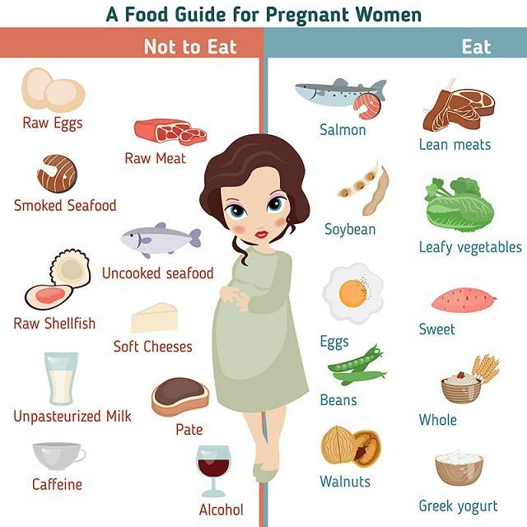

When possible, substitute fruits and vegetables with [organically grown produce](https://www.sitarambhartia.org/blog/pregnancy-diet-organic-food/) that are free from harmful pesticides and chemicals.

**How Much You Should Eat During Pregnancy?**

You only need an extra 300 calories and additional 15-20 gms of protein daily in the second and third trimester during pregnancy. The recommended portions vary as per individual requirements and medical conditions.

Your plate should consist of 50% fruits and vegetables (little or no oil), 25% whole grains, and 25% lean protein. Limit your oil intake to 4 tsp per day. Make sure you consume a dairy product in each of the 3 major meals and choose healthy snacks in between.

It is extremely important to stay well hydrated. You should drink 8 to 10 glasses of water per day.

**When You Should Eat?**

You should eat small balanced meals every 3-4 hours, with a light snack in-between. Remember not to skip meals or fast during pregnancy.In case you are still unsure of what to eat during pregnancy, choose from our recommended food combinations and add them to your own pregnancy diet plan.

**Sample Diet Chart for Healthy Women**

This is a sample Diet chart for a healthy woman requiring 2000 calories and includes extra 300 calories required in the second and third trimester.

**Sample Diet chart 2000 calories**

**Early morning before breakfast** – 4 Almonds

**Breakfast –**

* Dalia 1 Katori/ poha/ upma with vegetables/ 2 bread slices with vegetables and hung curd dressing/ 2 small rotis with vegetables stuffing
* Milk - 1 cup/ curd ½ katori + 1 egg or paneer 40gms

**Mid Morning - 2 fruits**

**Lunch –**

* Salad 1 plate
* Dal 1 katori
* Vegetables 1 katori
* Curd/ veg raita 1 katori
* 2 Roti/ rice 2 katori

**Evening snack-**

* Milk 1 cup – 150 ml
* Bhuna chana ½ katori/ 1 Besan chila/ 1 boiled egg white/ sprouts ½ katori
* Late evening - 1 fruit

**Dinner-**

* Salad 1 plate
* Green leafy vegetables 1 katori
* Dal sabut/whole 1 katori
* Roti 2 medium
* Curd/ raita 1 katori

**Bed time-** Milk 1 cup

**Sample Diet chart 2500 calories for underweight women**

**Early morning before Breakfast -**Milk 1 cup(150)ml + 5 Almonds

**Breakfast –**

* Dalia 1 Katori/ poha/ upma with vegetables/ 2 bread slices with vegetables and hung curd dressing/ 2 small rotis with vegetables stuffing
* Milk - 1 glass(250ml) / curd 1 katori + 1 egg or paneer 50gms

**Mid Morning - 2 fruits medium size**

**Lunch –**

* Salad 1 plate
* Dal 1 katori
* Vegetables 1 katori
* Curd/ veg raita 1 katori
* 3 Roti/ rice 3 katori

**Evening snack-**

* Milk 1 glass – 250 ml
* Bhuna chana 1 katori/ 1 Besan chila/ 1 boiled egg white/ sprouts 1 katori
* Late evening - 2 fruit

**Dinner-**

* Salad 1 plate
* Green leafy vegetables 1 katori
* Dal sabut/whole 1 katori
* Roti 3 medium
* Curd/ raita 1 katori

**Bed time-** Dessert 1 katori (milk based with fruits)/ Milk 1 cup + 1 fruit